

Tyler John Photography

https://www.tylerjohnphotos.com/rocky

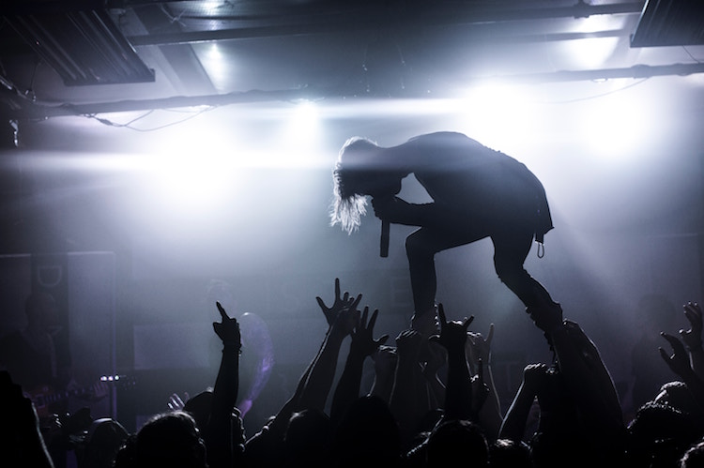

Posted: 01/03/2013

Rocky Riggs Concert, 2012

Photography by Tyler John

Scroll down to view the second source



5540987

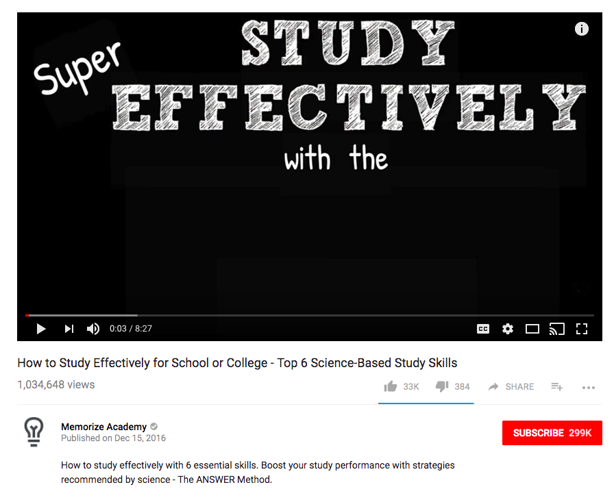

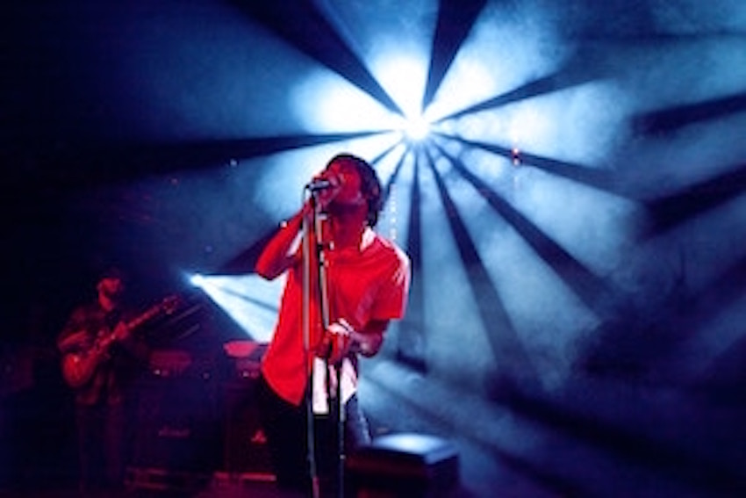

Rocky in L.A. 12/1/14

Filmed by

Gina Lopez



Rocky Riggs live in L.A. What an amazing concert!

ConcertGal

Published on Feb 8, 2017

680,011 views

0:04 / 23:14

Rocky in L.A. 12/1/14